Upgrading Software for the RPG-HATPRO, RPG-LWP, RPG-U90, RPG-150-90, RPG-DP150-90, RPG-HUMPRO, RPG-TEMPRO Radiometers

Assumption: You want to install a new radiometer software version (2CH.EXE) on the embedded radiometer PC and a new version of R2CH.EXE on the host PC.

1. Step: Save the old software versions

a) Create a directory to save the old software versions (e.g. C:\MyPath\RPG-HATPRO\SAVE).
b) Connect the host to the radiometer and enter the File Transfer Menu (, Fig.1). On the right side (Host) browse to the directory for saving the files (e.g. C:\MyPath\RPG-HATPRO\SAVE) and on the left side (Radiometer) in the System Files Directory mark the 2CH.EXE file. Then press the ‘>>’ button to initiate the copy process.

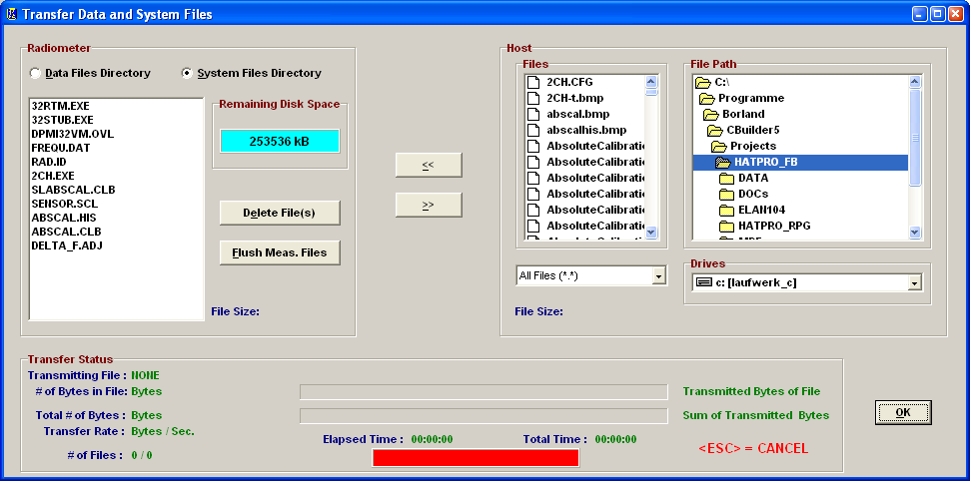

Fig.1: File Transfer Menu

c) locate the R2CH.EXE file in the MyPath\RPG-HATPRO directory and copy this file to the C:\MyPath\RPG-HATPRO\SAVE directory.

2. Step: Overwrite the old versions by the new ones

- Terminate R2CH.EXE and overwrite the old R2CH.EXE in MyPath\RPG-HATPRO with the new version.
- Execute R2CH.EXE to start the new host version.
- Copy the new version of 2CH.EXE (the radiometer PC software) on an arbitrary directory on your hard disk (e.g. MyPath\RPG-HATPRO\ELAN104). Then enter the file transfer menu in Fig.1 and browse to that directory. Mark the 2CH.EXE file in the Files-list and press the “<<” button. Because you are now going to overwrite a file in the System Files Directory (which is password protected for write access) a password entry window pops up. Please enter the following password in exactly the way as it is printed here:

theringsofsaturn

Press OK and the 2CH.EXE on the radiometer PC will be overwritten by the new 2CH.EXE version. Exit the File Transfer Menu after that.

- Boot the radiometer PC to make the new 2CH.EXE the running version. You can do this by entering the Manual Control Menu () and selecting the “Dew Blower + System” tag. Press the “Reset Radiometer PC” button and confirm the command with YES. Wait for about 2 minutes to give the boot process time enough to finish. Then reconnect to the radiometer (). The Radiometer Status box now indicates the new radiometer software version.

The software upgrade is finished.

